**Introduction to Linux**

The families and representative distributions we are using are:

* Red Hat Family Systems (including CentOS and Fedora)
* SUSE Family Systems (including openSUSE)
* Debian Family Systems (including Ubuntu and Linux Mint).

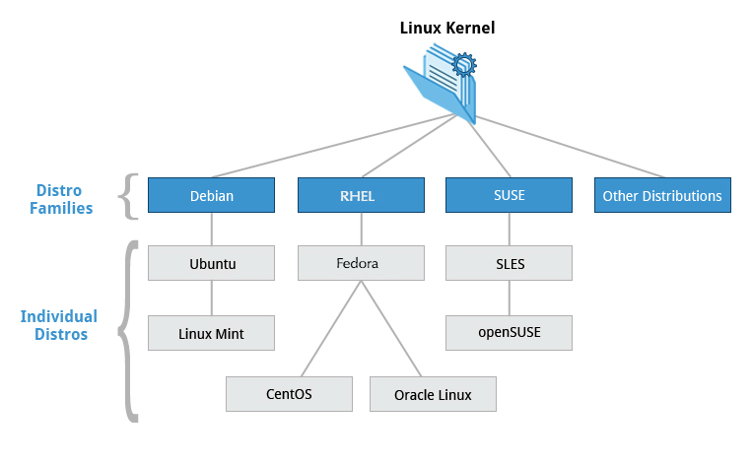

The Linux Kernel Distribution Families and Individual Distributions